ASSIGNMENT 1

Name: Hemanth Kumar Nimmakayala
Roll no: 22AK1A3323
Course: Data Analytics with Tableau
Title: Plugging into the Future: An Exploration of Electricity Consumption Patterns Using Tableau

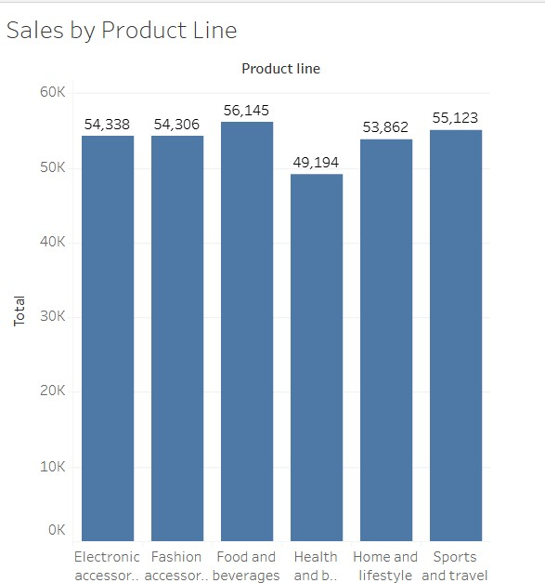

Fig: Bar Chart

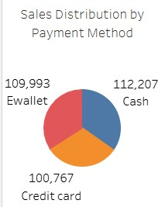

Fig: Pie Chart
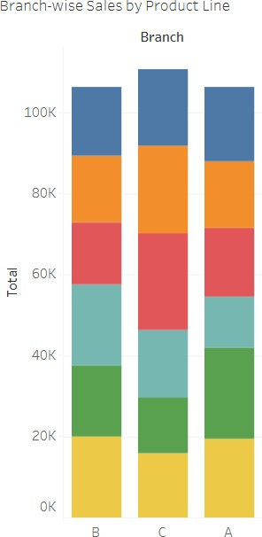

Fig: Stacked Bar Chart

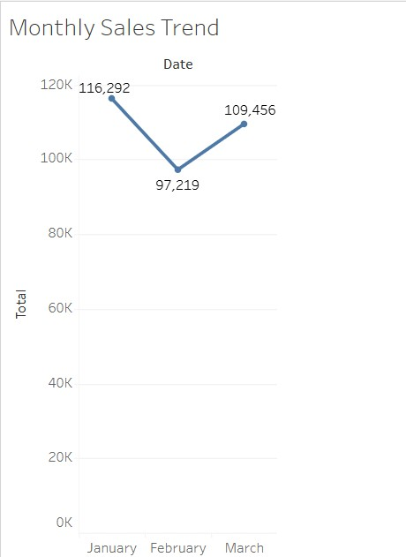

Fig: Line Chart
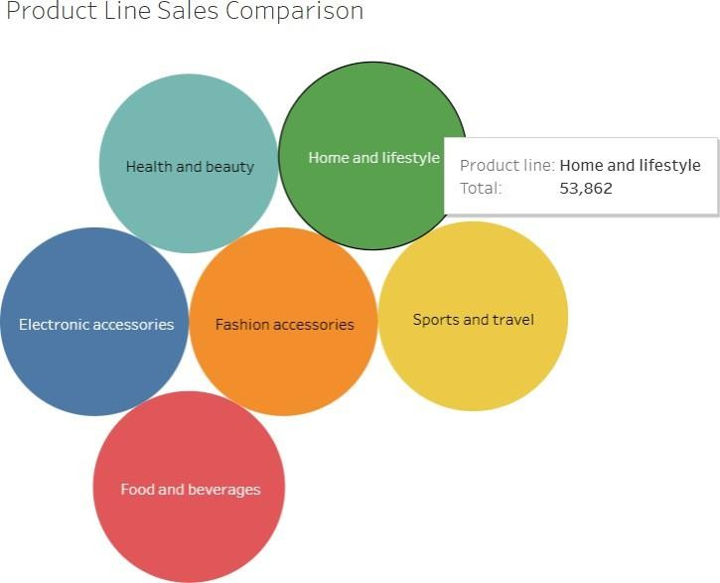

Fig: Bubble Chart

ASSIGNMENT 2

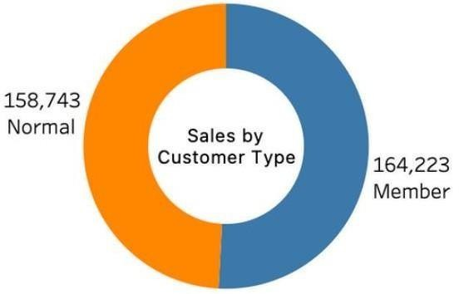
Fig: Donut Chart

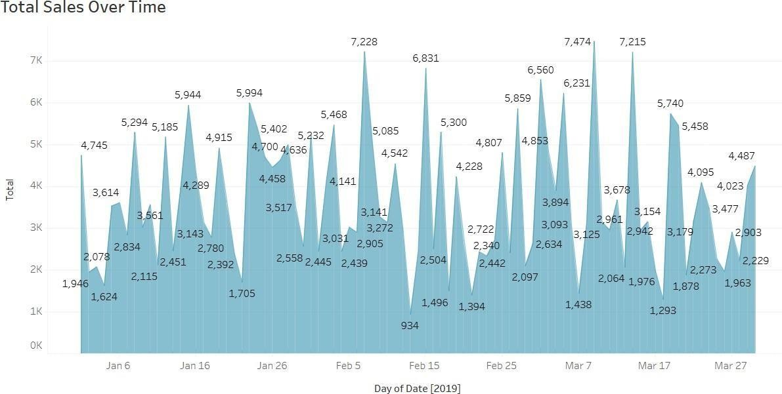

Fig: Area Chart
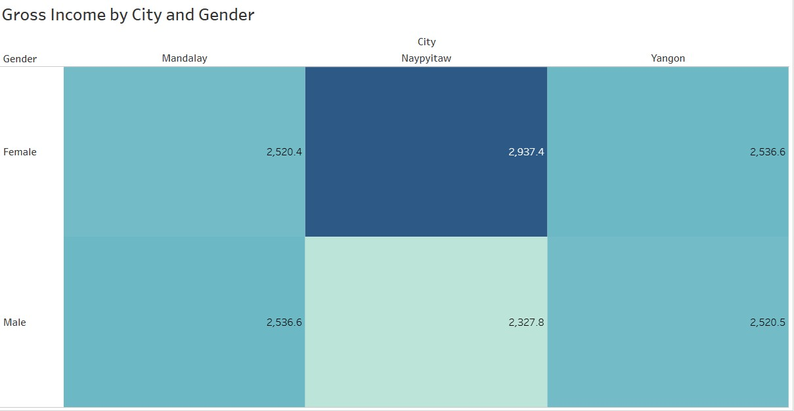

Fig: Text table

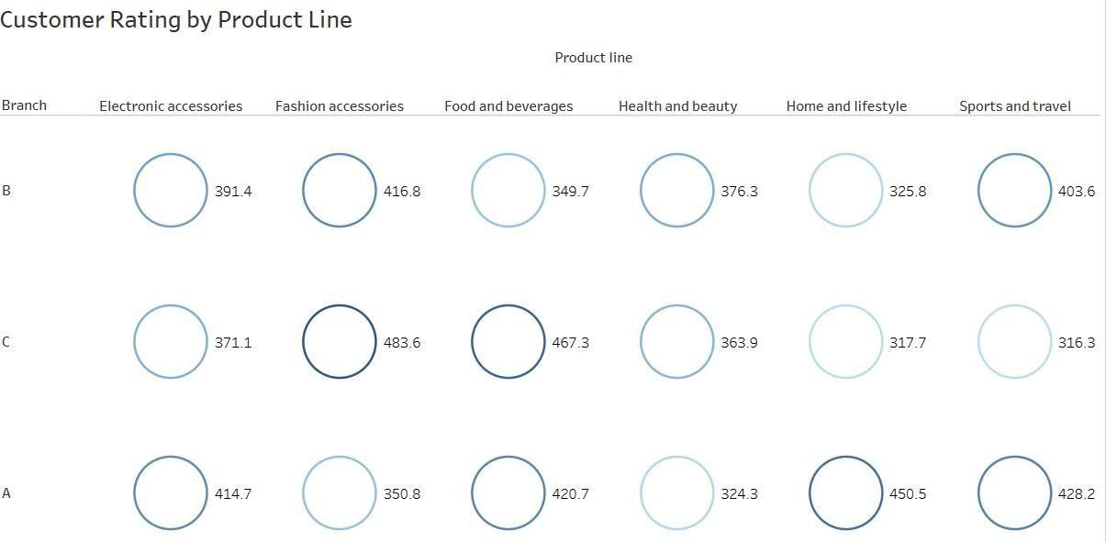

Fig: Highlighted table


Fig: WordCloud

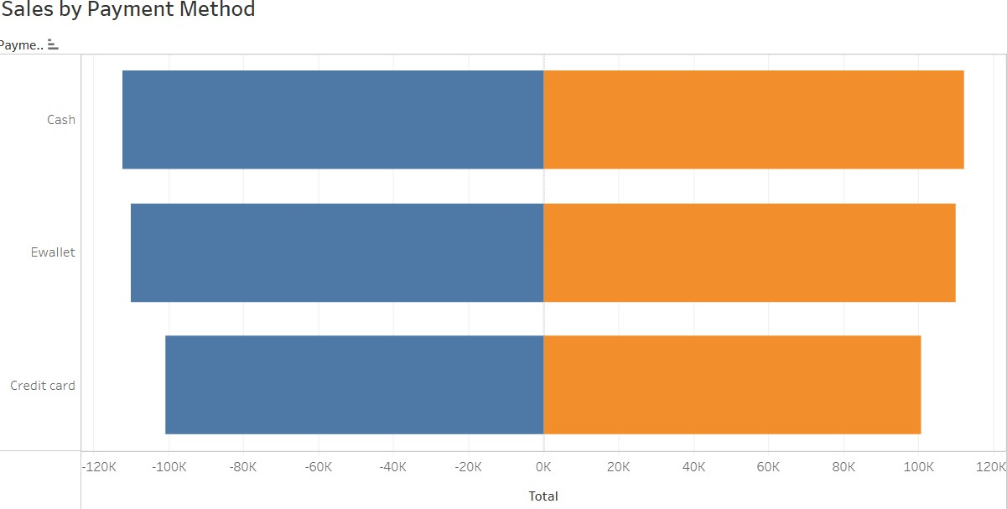

Fig: Funnel Chart
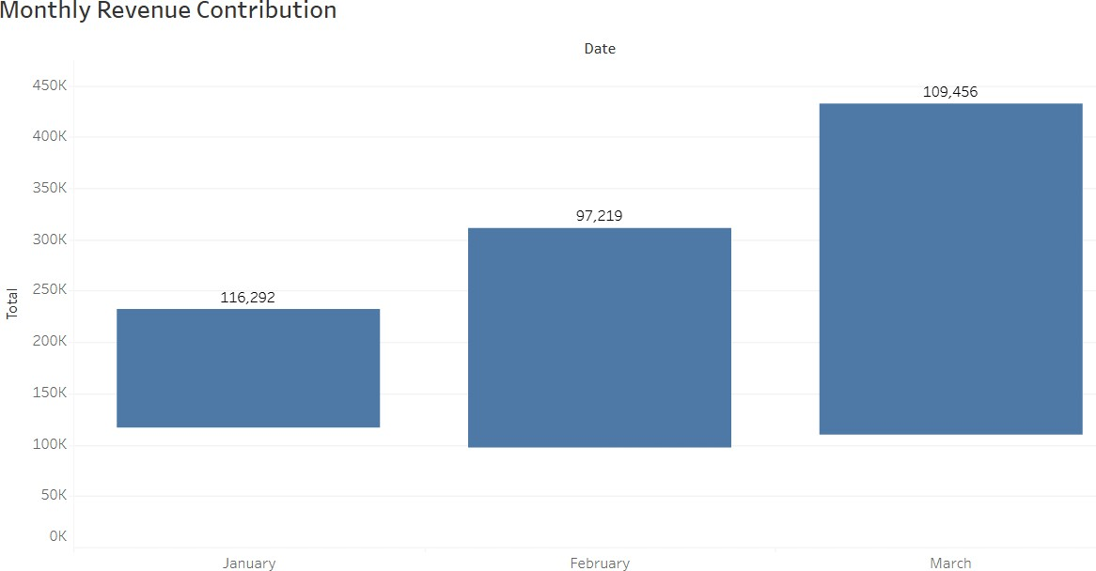
Fig: Waterfall

